Local Campus New Faculty Certification

Faculty Web Scavenger Hunt
Your certification facilitator will tell you if you should complete this activity outside of, or as part of, the scheduled Workshop Two certification meeting.
- Find a copy of the current Learning Team Charter.

Located at https://ecampus.phoenix.edu/secure/modules/learningTeam/LearningTeamCharter_web.pdf
within the Faculty Forms web document:
https://ecampus.phoenix.edu/secure/faculty/facforms.asp

- What are the eligibility requirements for the Faculty Stock Options Award Program?
Defined for different classes of faculty membership in the Faculty Handbook 2007 version in section 6, pp 67-68. Eligibility requirements are too numerous to list. Associate (new) faculty are apparently not defined in handbook, but online. Cannot find the web page where award eligibility is online.

- What are the alternative methods of final course grade entry?
Page 20 of the University of Phoenix Grading, Evaluation and Feedback Manual indicates that “Faculty members should submit student grades using the Faculty Web site, http://ecampus.phoenix.edu. By choosing the Services tab, faculty members can enter grades by Group ID or the student’s last name.”

- When is the next commencement for your campus?
The date and time for the 2008 ceremonies was 19 July, at two different times, found here: http://phoenix.edu/graduation/ There is no indication of the next graduation date.

- Find a direct deposit form.
https://ecampus.phoenix.edu/secure/faculty/forms/DirectDepositForm.doc found on
https://ecampus.phoenix.edu/secure/faculty/facforms.asp, by all appearances, would be adequate to the task.

- What is the title of section three of the Faculty Handbook?
On page 32 of the 2007 version, it is FACULTY ASSESSMENT AND DEVELOPMENT.

- Locate the available faculty Web-based trainings. List three training titles.
On the page https://ecampus.phoenix.edu/secure/facTrain/traininglinks.asp a count of 17 training modules were found. Picking three at random: Diversity Tutorial, Preventing Sexual Harassment, Copyright Tutorial.
- What is rEsource?
Page 39 of the 2007 Faculty Handbook (emphasis added):
University of Phoenix created rEsource—an electronic portal designed to increase and enhance learning by organizing objectives, materials, and assignments in a manner that allows for improved comprehension and increased value to the faculty and students.
- What is the phone number for students to use to contact University of Phoenix Technical Support?
From a MS Word-formatted document titled Online Learning System Forum Information for Local Campus Class Faculty, a sample Main Forum message to be posted for the benefit of students in the class reads at the final line: “The tech support staff are available 24/7 by calling 1-877-TECH-UOP (1-877- 832-4867)”

- What should you do if you forget your login or password?
In the panic of having forgotten, one might click the “Forgot Password?” button and get the form located here: https://mycampus.phoenix.edu/content/UOP1.0/Content/NewPassword.do
One problem is that it requires perhaps the knowledge of the IRN or user name. No information found for what to do about forgotten username or IRN number

- Access the University Library.

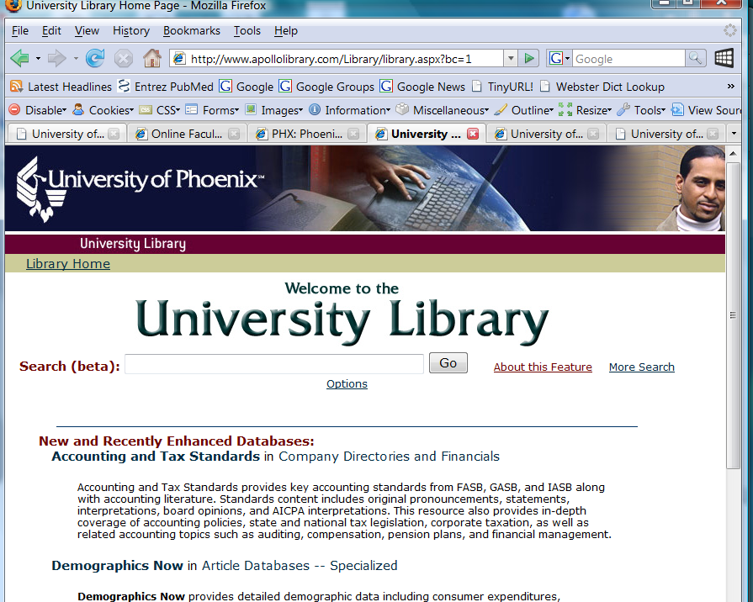

- Using a major database in the library, find an article pertaining to e-learning.

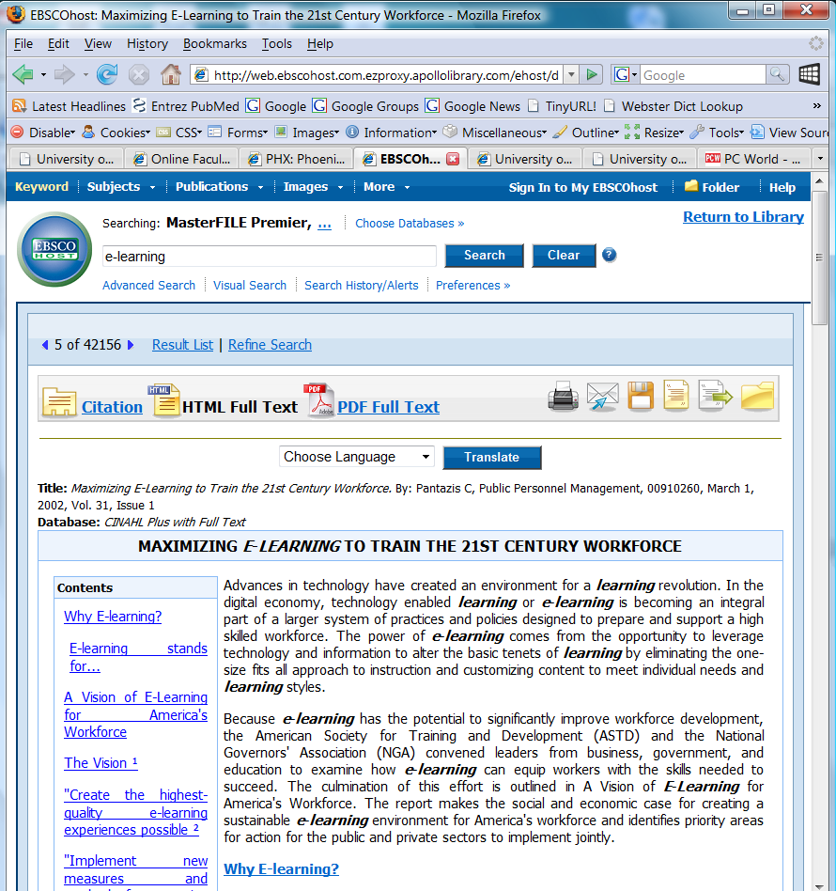

- Find information on creating a syllabus for a university class.
At the Online Faculty Resource virtual host site, one gains access to instructions on syllabus preparation from a script-loaded page series that starts at http://corptrain.phoenix.edu/faccertuop/week1/Preparing_Syllabus_1.htm. This is not delivered as the page itself, but within a structured panel. Also page 55 of the 2007 Faculty Handbook stresses to the instructor that the syllabus must contain warnings to the students about academic dishonesty and plagiarism, with references to official University policy about these matters.

- What are the mission and purposes of University of Phoenix?
The most logical place to look for such information would be a university catalog or a faculty handbook, and being consistently logical, usually that stuff is at the start of the document. Indeed, at the start of Section 1 of the 2007 Faculty Handbook (p. 7). Reproduced here below verbatim:

MISSION AND PURPOSES
MISSION
The Mission of University of Phoenix is to provide access to higher education opportunities that enable students to develop the knowledge and skills necessary to achieve their professional goals, improve the productivity of their organizations, and provide leadership and service to their communities.
PURPOSES
■ To facilitate cognitive and affective student learning—knowledge, skills, and values—and to promote use of that knowledge in the student's work place.
■ To develop competence in communication, critical thinking, collaboration, and information utilization, together with a commitment to lifelong learning for enhancement of students' opportunities for career success.
■ To provide instruction that bridges the gap between theory and practice through faculty members who bring to their classroom not only advanced academic preparation, but also the skills that come from the current practice of their professions.
■ To provide General Education and foundational instruction and services that prepare students to engage in a variety of university curricula.
■ To use technology to create effective modes and means of instruction that expand access to learning resources and that enhance collaboration and communication for improved student learning.
■ To assess student learning and use assessment data to improve the teaching and learning system, curriculum, instruction, learning resources, counseling and student services.
■ To be organized as a for-profit institution in order to foster a spirit of innovation that focuses on providing academic quality, service, excellence, and convenience to the working adult.
■ To generate the financial resources necessary to support the University’s mission.

- Use your Individual Forum to post a private message for your facilitator telling him or her you have completed this exercise!
Done

Copyright 2004, 2008 University of Phoenix. All rights reserved.

